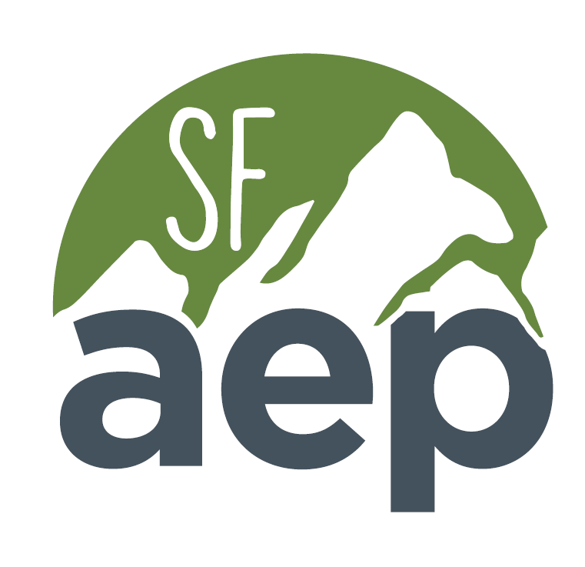  To  Enhance,  Maintain,  and  Protect  the  Natural  and  Human  Environment | 2024 AEP Student Scholarship
The Association of Environmental Professionals (AEP) is a non-profit organization of professionals whose goal is working to improve the skills of environmental practitioners and natural resource managers. The San Francisco Bay Area Chapter is dedicated to supporting students who are planning to engage in a career in the environmental field.
As part of our support endeavors, we are offering scholarships to students pursuing a career in the environmental field. We are pleased to offer at least one $2,000 scholarship to an undergraduate student and at least one $2,000 scholarship to a graduate student. Additional scholarships may be awarded based on available budget.
AEP is currently offering complimentary Student Memberships! AEP membership is required to receive the scholarship. To become a member, visit: https://www.califaep.org/membership.php
$2,000 Award
for a full-time undergraduate and graduate student
Who can apply?
- Full-time current undergraduate or graduate students who are actively engaged in the pursuit of a career with an environmental emphasis.
- Only full-time students who are attending an accredited college or university within the counties served by the San Francisco Bay Area Chapter (San Francisco, San Mateo, Alameda, Contra Costa, Solano, Napa, Sonoma, Marin, Lake Mendocino, Trinity, Humboldt, and Del Norte) will be eligible. (Please note that Santa Clara County is no longer in our service area but is part of the Monterey Bay – Silicon Valley Chapter of AEP).
- A minimum cumulative GPA of 3.0 is required.
- AEP student membership (free) is required.
How can the money be used?
The award can be used for any aspect of education including tuition, books, housing, research, etc. The recipients will receive a check in their name from the SF Bay Area Chapter of AEP in summer 2024.
How do I apply?
The application form is attached below and is available for download in MS Word and PDF format at: https://sf.califaep.org/students.php

All application materials must be submitted via email by June 30, 2024 to aep.sfbayarea@gmail.com.

Questions related the scholarship should be emailed to Karly Kaufman, Student Scholarship Coordinator, at the email address listed above.
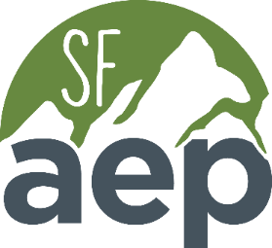
Association of Environmental Professionals – San Francisco Bay Area Chapter
sf.califaep.org
2024 AEP Student Scholarship Application Form
General Information
Name
Address
City |  |  |  |  |  | State |  |  | Zip
Phone
Email
College/University Attendance (list most recent first)
 | School Name |  |  |  | Dates of Attendance |  |  | Degree/Major |  |  | GPA

Other Questions
Are you currently an undergraduate or graduate student? Undergraduate □ Graduate □
Are you currently receiving financial aid? Yes □ No □
How would you rank your financial need? Low □ Medium □ High □
Are you currently an AEP member (AEP membership is required)? Yes □ No □

Association of Environmental Professionals – San Francisco Bay Area Chapter
sf.califaep.org

Application Materials:
A complete application packet includes the following in the order listed in one PDF document titled as seen here: LastName.FirstName-2024SFAEPScholarship.
- APPLICATION FORM. This form, completed.
- TRANSCRIPTS: Transcripts should be included in the application submittal. Website printouts of unofficial transcripts will be accepted.
- LETTER OF RECOMMENDATION: One letter of recommendation from an environmental professional or a school professor who is not related to you. The letter must be on corporate letterhead or school letterhead and include a signature. (Can be submitted separately).
- RESUME: A one-paged resume/curriculum vitae (CV) summarizing your background including education, training, internships, volunteer, and work experience
- ESSAY: A two-paged double-spaced essay with no smaller than 12-point font and 1 inch margins on all sides. The essay should address the following:
- Environmental issues you feel are important. What do you think are the 2 or 3 more critical environmental challenges currently facing California?
- Your career goals as they pertain to environmental issues, including education, training, internships, volunteer, and work experience; such as how your goals would relate to AEP’s mission to “enhance, maintain, and protect the natural and human environment.”

All application materials must be submitted via email by June 30, 2024 to Karly Kaufman, Student Scholarship Coordinator, aep.sfbayarea@gmail.com for consideration. Scholarship announcements will occur within approximately one month of the application deadline.

